EXP 2 : GENERATION OF SQUARE WAVE USING PROTEUS
AIM:
To write an assembly language program to Generate square wave using AT89C51

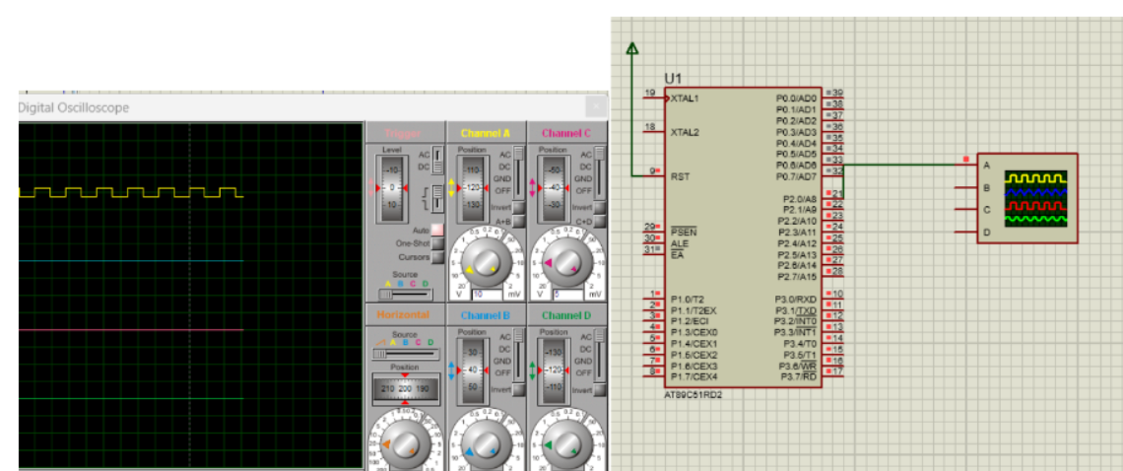

RESULT:
Thus the program has been successfully verified and executed

